University College of Engineering Tindivanam

**Create Google My Business Account**

**Team Lead: Dharani K** 8D7A0A9278D31CE87DA4C3FD395618B3

**Team Members:Archana A**

94D21F91CFAA4AE964942C07BB93EF7F

**Nithyasripriya R**

1558F2FC758D25797E848397C29EE74A

**Pradeepa S**C24D59CF412A85891A94F86A3FE517A1

**Step 1:**

**Step 2**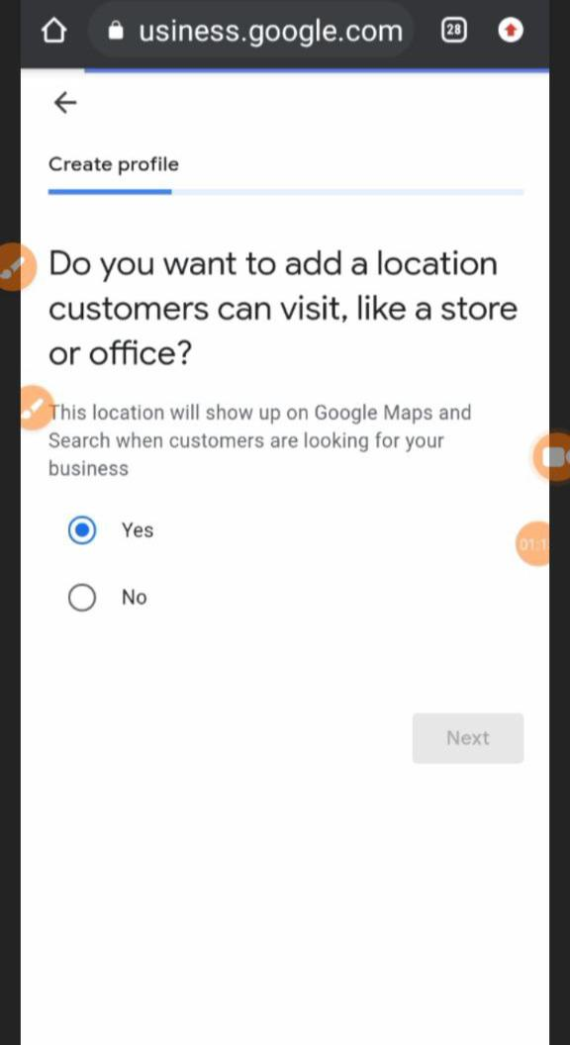

**Step 3:**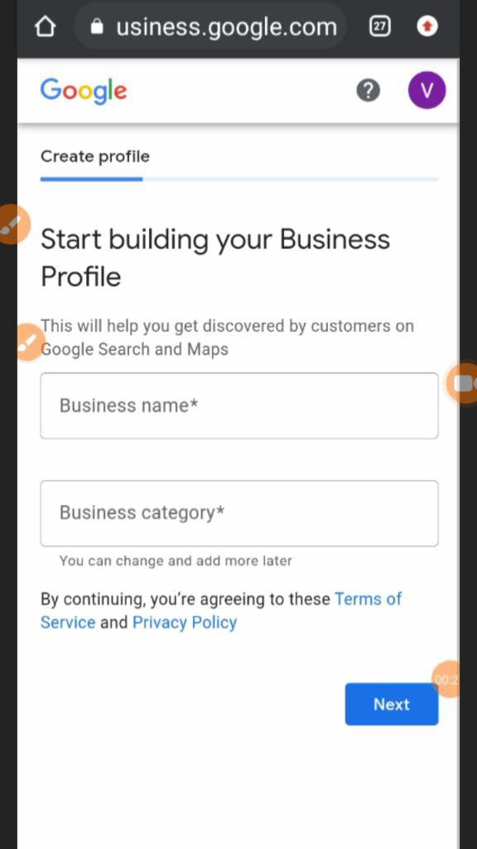

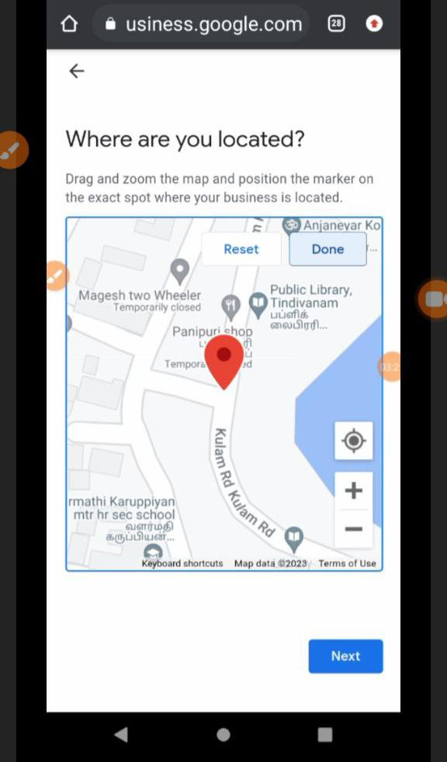**Step 4:**

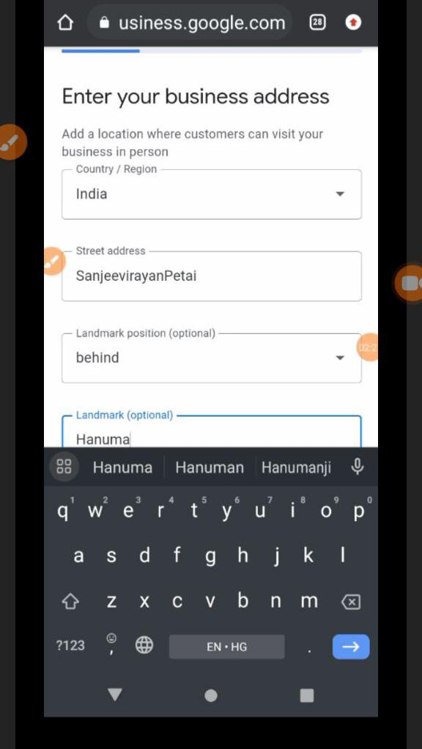**Step 5:**

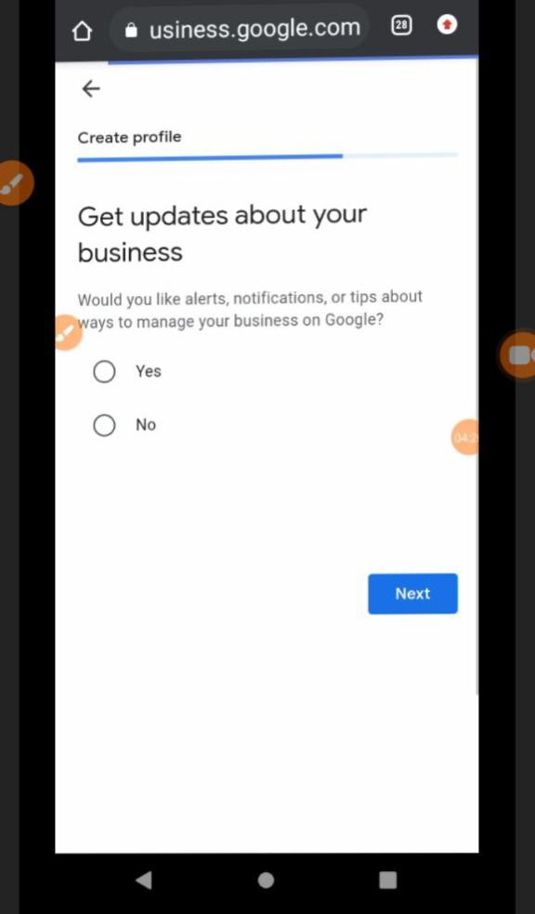**Step 6:**

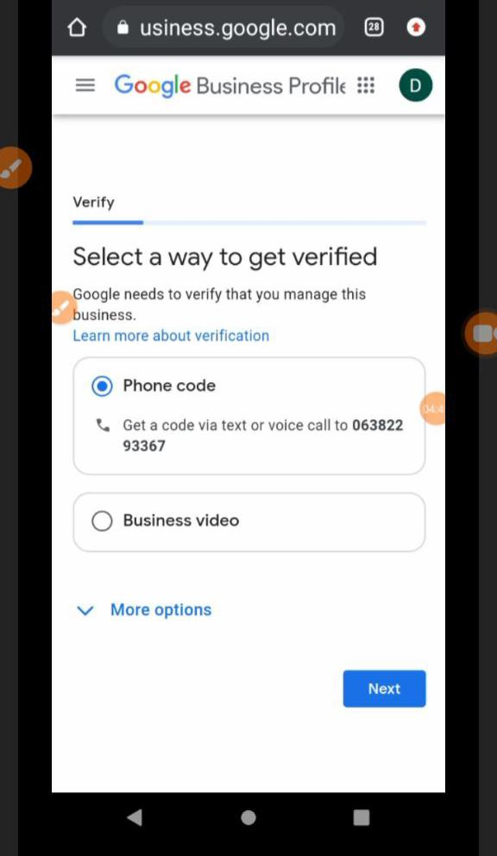**Step 7:**

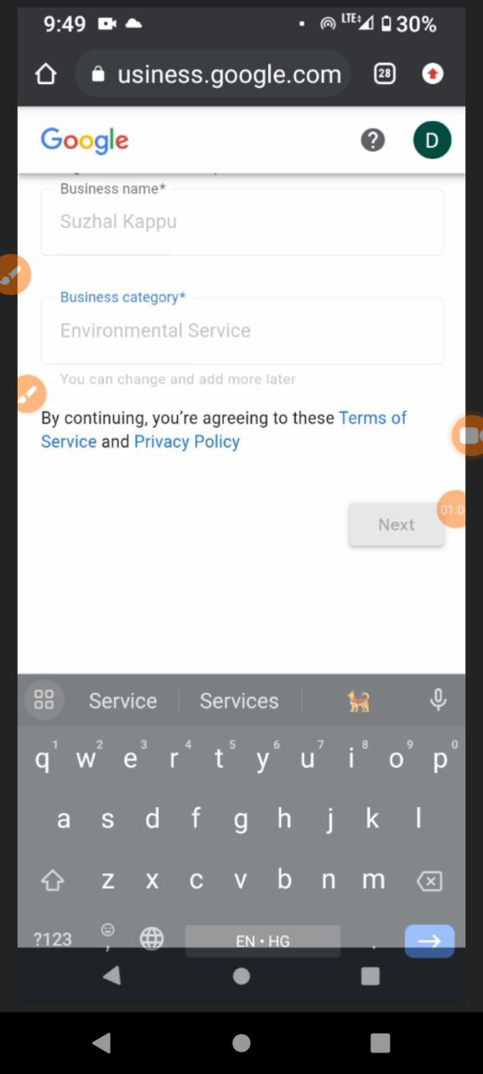**step:8**

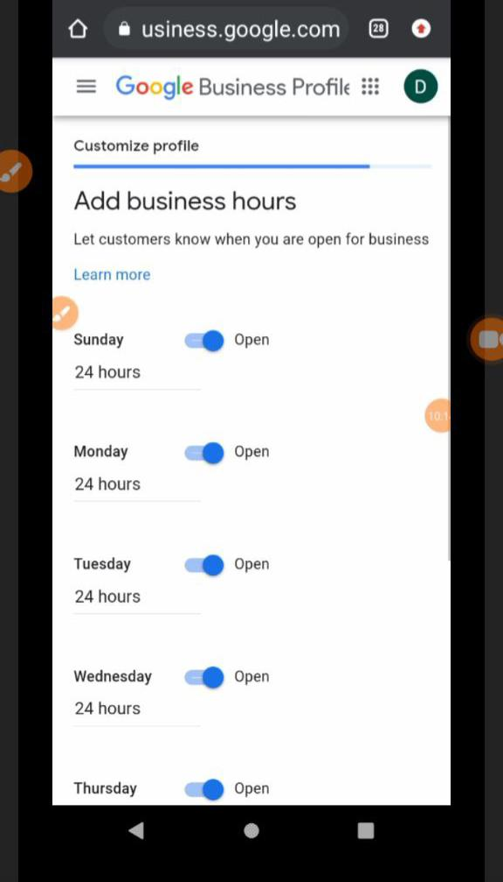**step:9**

**Step 10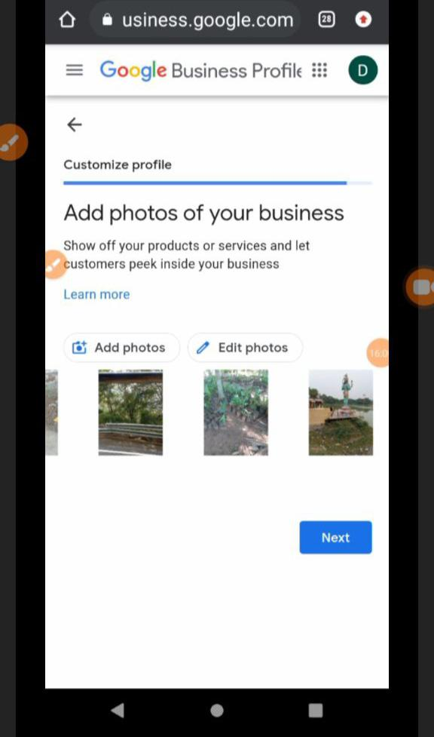:**

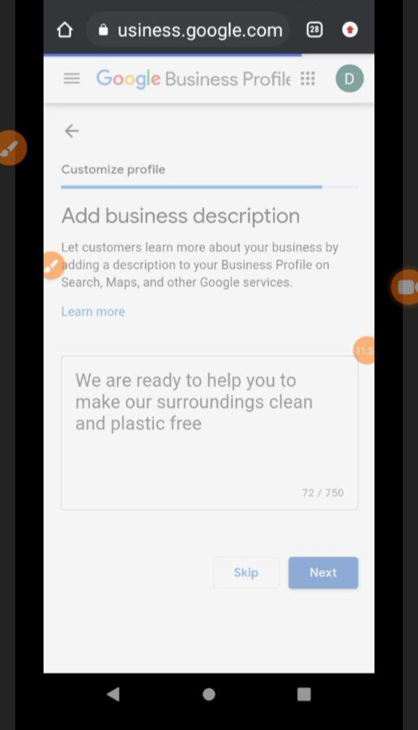**Step 11:**

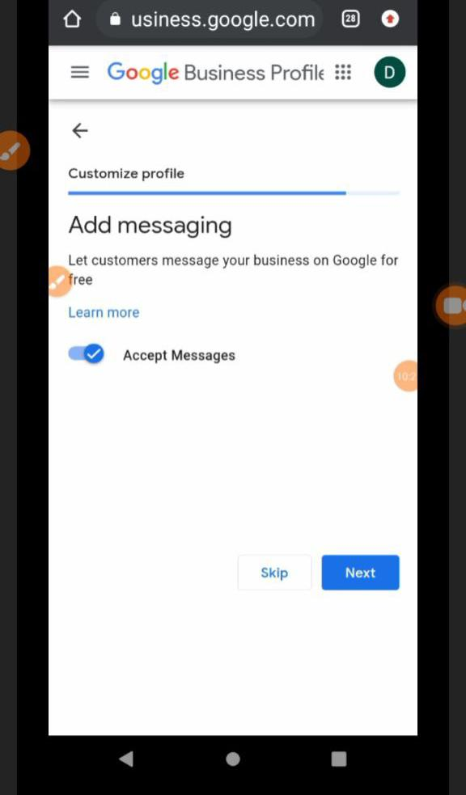**Step 12:**

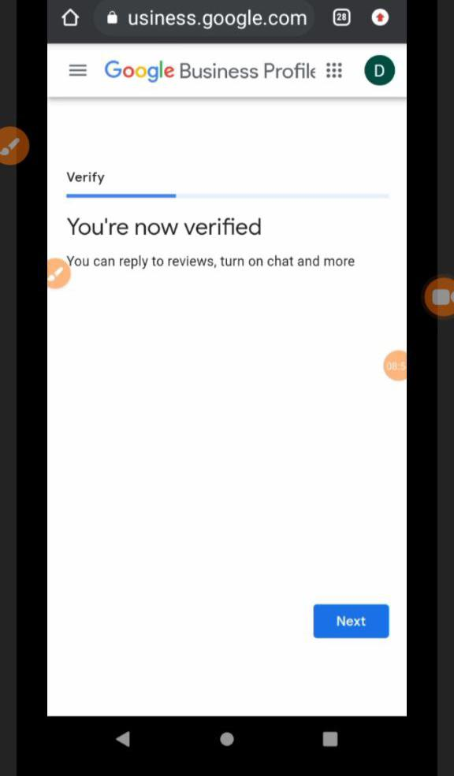**Step13:**

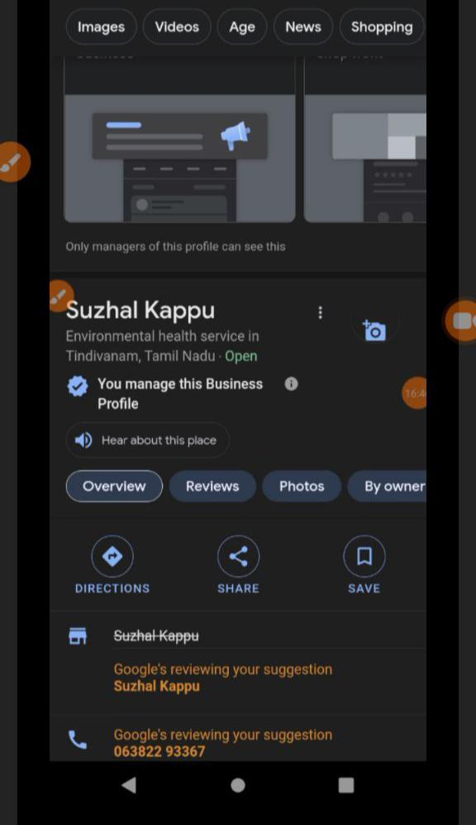**Step 14:**

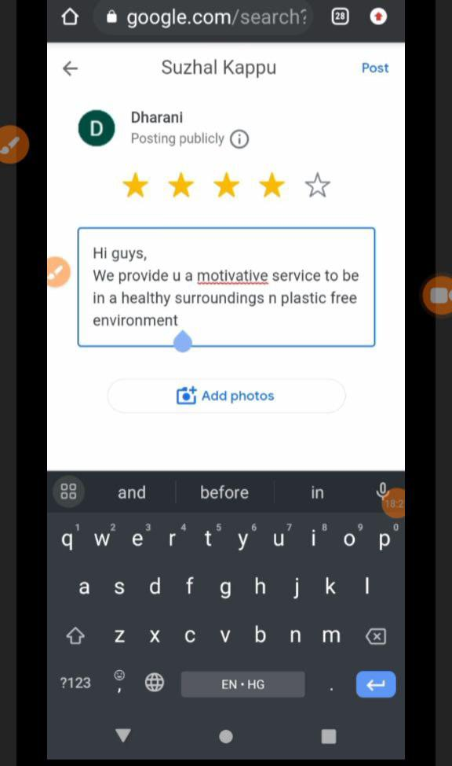**Step 15:**

